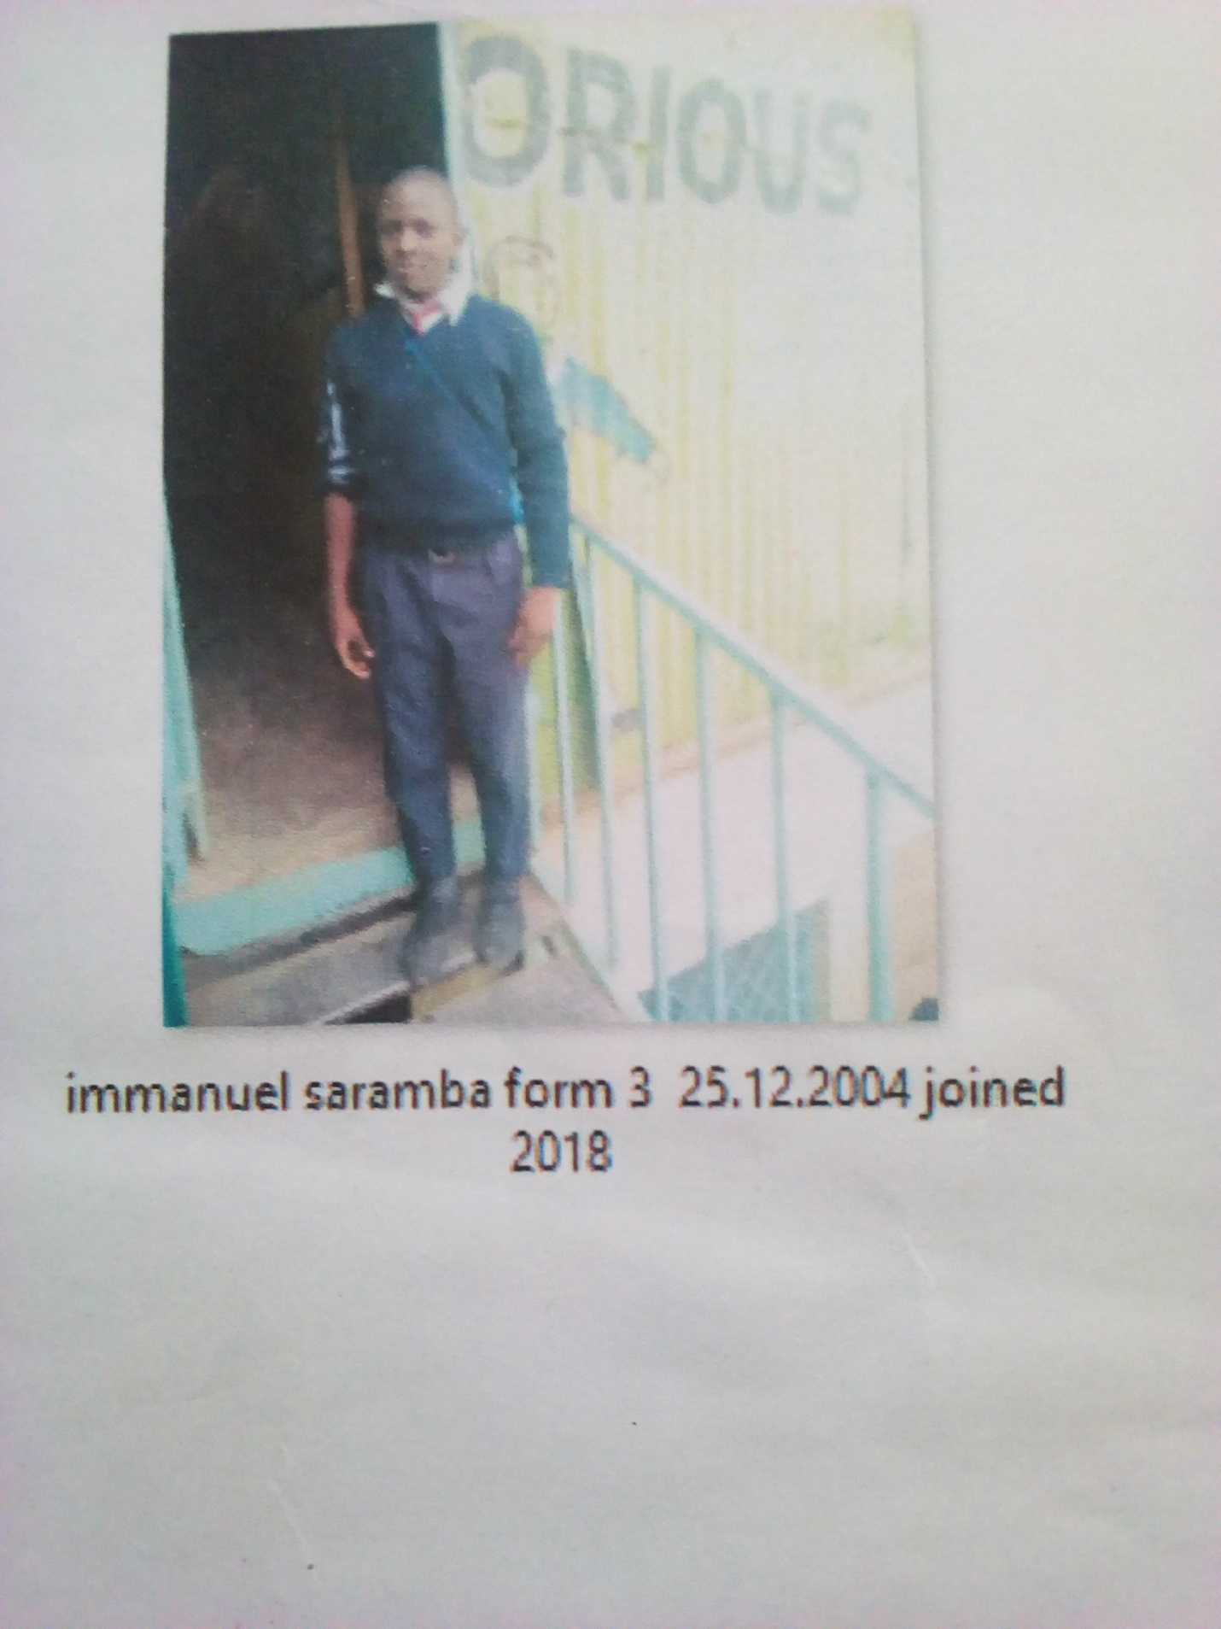
EMMANUEL SALAMBA FORM 2 BORN 2004 JOINED 2018
Emmanuel 17 years was enrolled in our school when he was 16 years old. Emmanuel is an orphan boy, picked from the streets of Mukuru kwa Reuben; Emmanuel looked miserable all hope had dried up in him. It happened after his was chased from their after the demise of his parents. He sought help in school and he became accepted in school after the Director was contacted.
Thanks to the Director Mr. Boniface Mangeti who allowed Emmanuel in school. I am now learning in glorious at least I have a place I call home praying that one day God will help our school have good classes, toilets and enough learning materials. Thank you Michell and Brad for your support have really helped many in Mukuru

